**Nitisha Omkar**

**Gh3717**

**Flip Book Group**

**Unit Test Performed for: signUpPage.php**

**Note: My group and I did not use Java, C++ or any language that uses classes and methods. We used HTML/CSS, PHP, and SQL. Instead of the original assignment, we emailed you and you gave us permission to each test out a page on our site and make sure that everything works properly and to report our results for that page. This includes testing out links, forms, functionalities, etc.**

I will be performing a unit test for the signUpPage.php file and I will be testing all available and visible fields, buttons, and links present on the page.

1. **Sign Up Button on index.php**

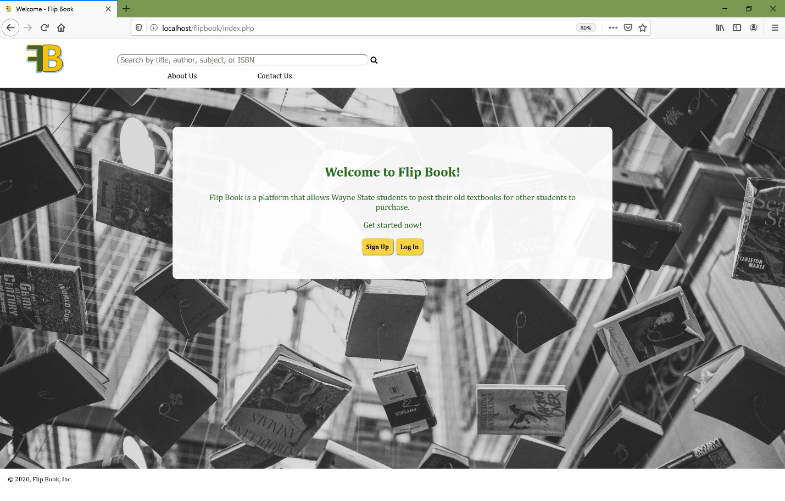As the sign up page is not the first page the user encounters when interacting with the Flipbook site, it will be my first step to test out the sign up button present on the index page. Here are the screenshots associated with this test:

Figure : Before pressing the sign up button:

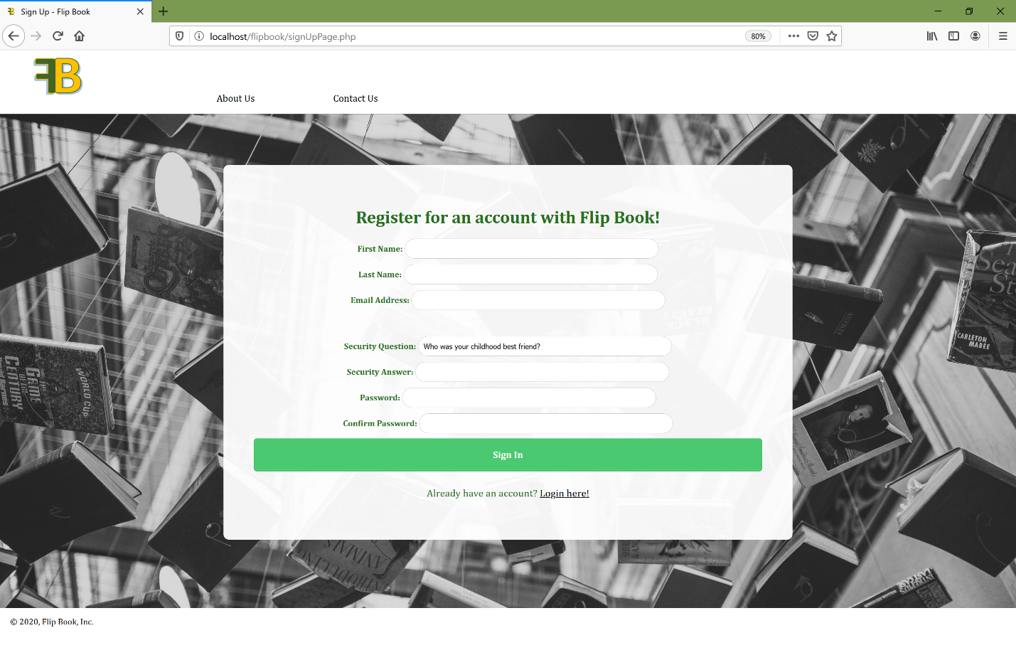

Figure : After pressing the sign up button

1. **Checking the about page hyperlink located near the FlipBook logo**

For my second feature I will be checking if the hyperlink for the about page is working properly. Here are the screenshots associated with this test:

Figure : Before clicking on the about link

1. 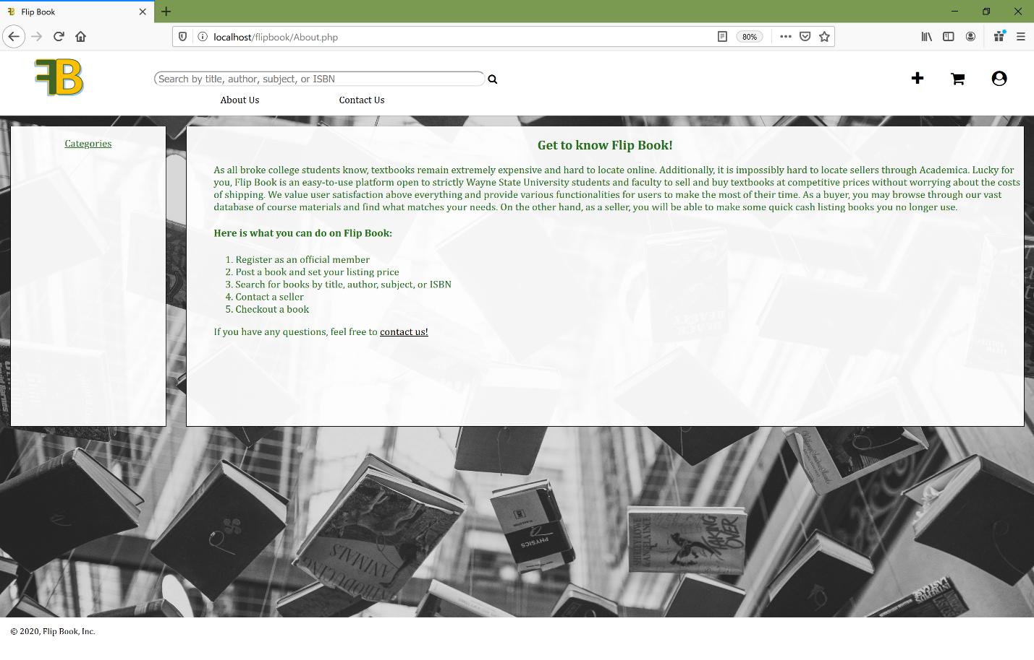**Checking the about page hyperlink located near the FlipBook logo**

Figure 5: Before clicking on contact us link

Figure 4: After clicking on the about page link

1. 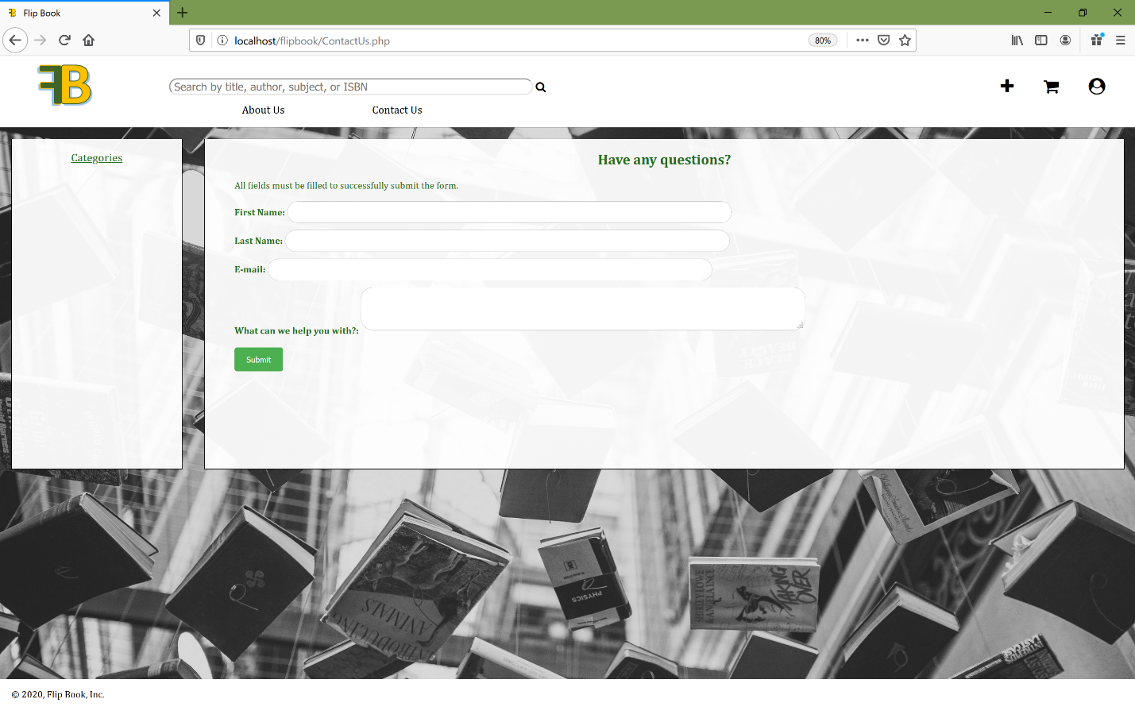**Checking to see if page responds to no response from a user**

Figure 7: Before pressing submit with blank fields

Figure 6: After clicking on the contact us link

1. 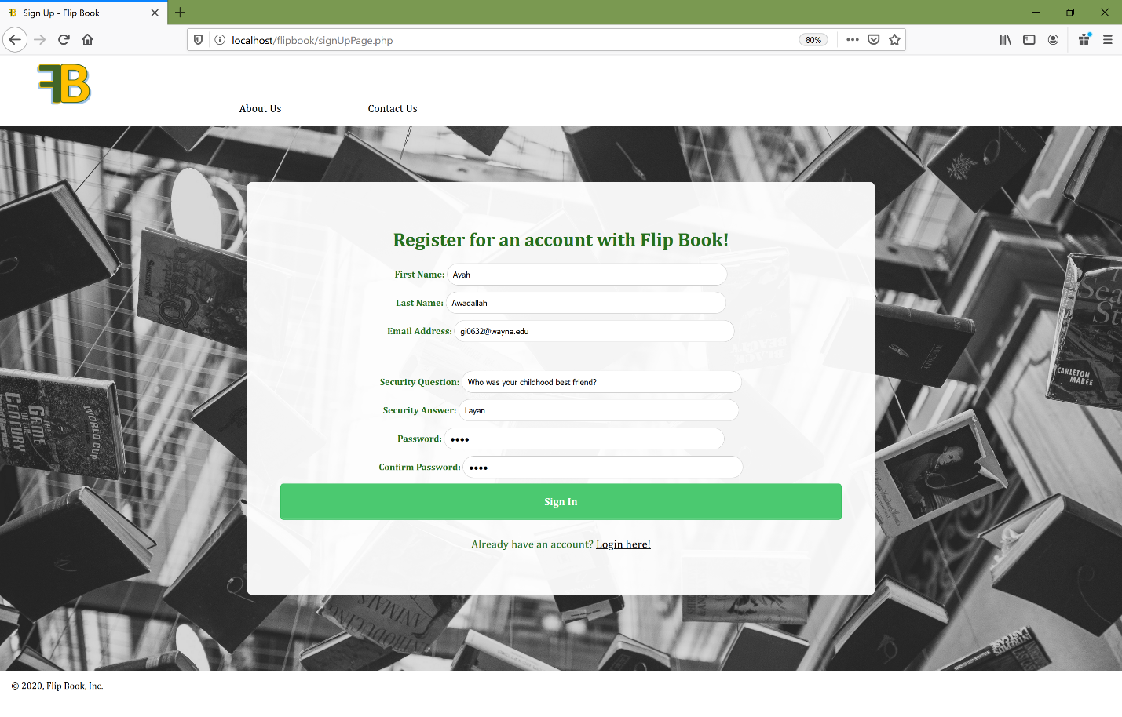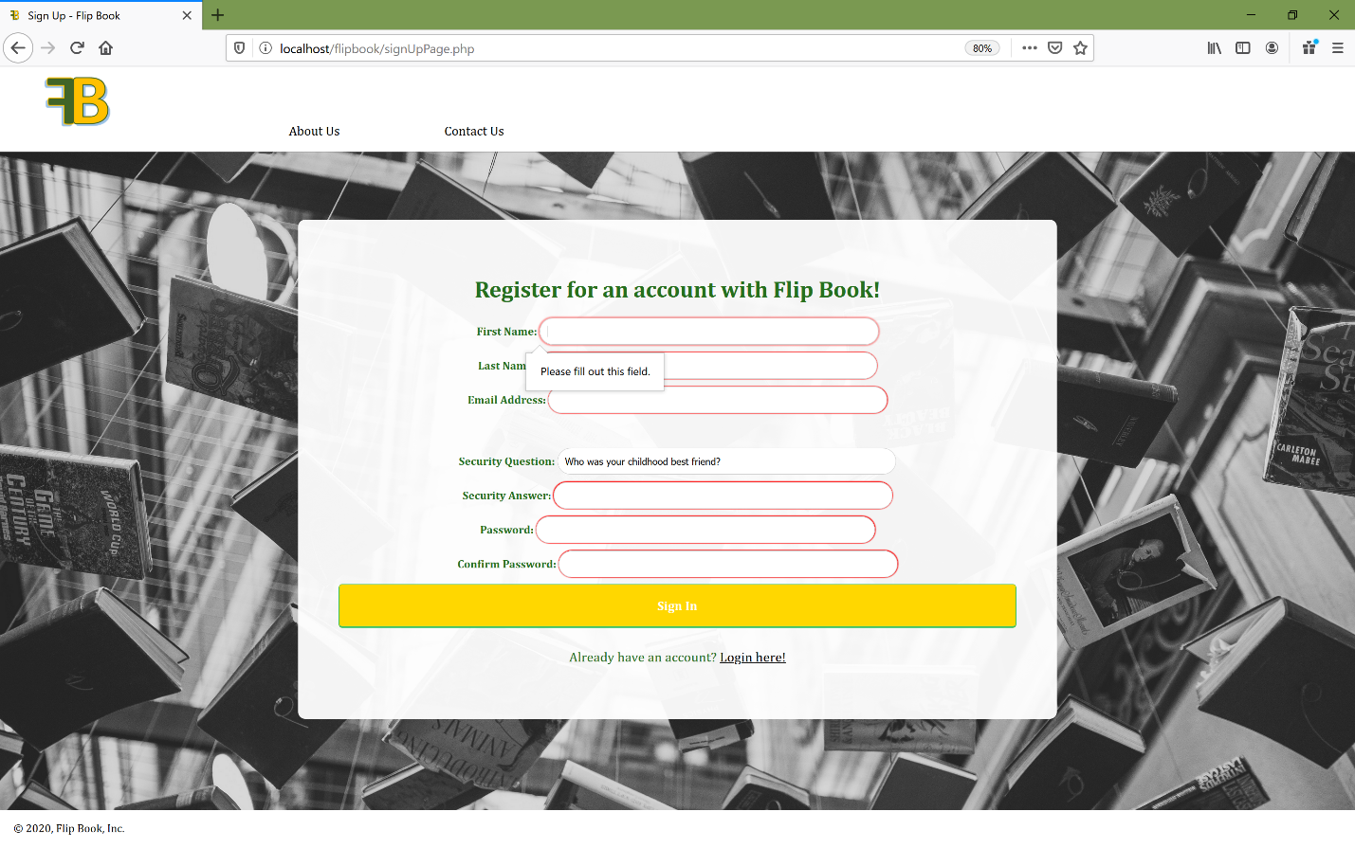**Checking to see if the form takes the user to the correct place after properly filling out the information. The user is supposed to be redirected to the login page after they submit valid information.**

Figure 9: Before submitting the information.

Figure 8: After trying to submit with empty fields

1. 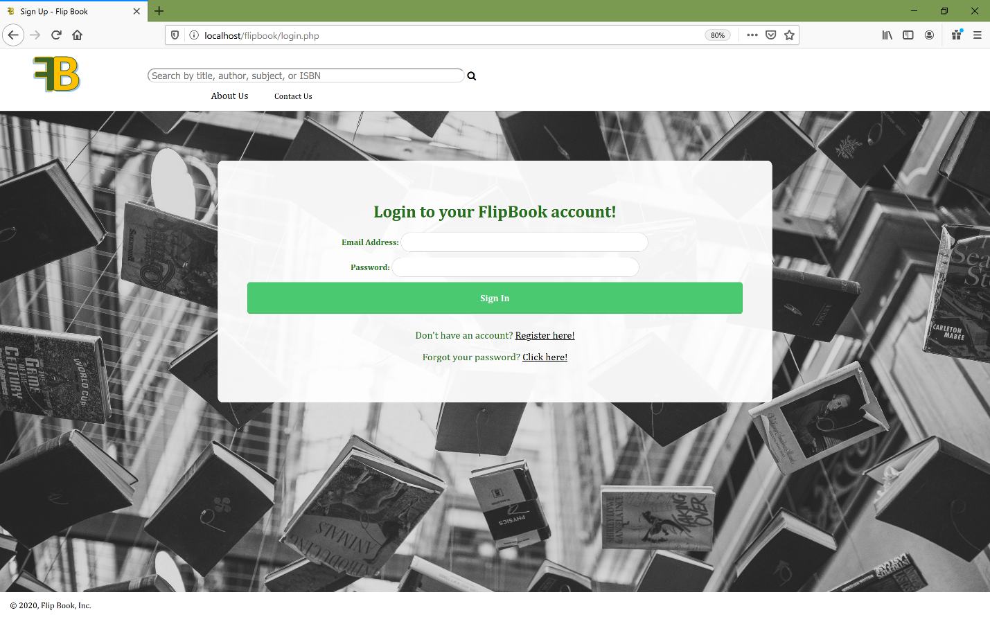**Checking if the login here link works (located under the form).**

Figure 11: Before clicking the login here link

Figure 10: After submitting the information.



Figure 12: After clicking on the login here link